# 

# STRENGTHENING COMMUNITY

# TODAY AND TOMORROW

# Steuben County ymca

# Online COMMUNITY NEEDS assessment – executive REPORT

At the Y, strengthening community is our cause. The Y as a national movement has listened and responded to communities’ most critical social needs for more than 160 years and it is determined to keep doing so. The most compelling community needs coupled with the desired impact the Y seeks to have in their community is at the crux of driving a Y’s strategic expansion and program development plans.

From May-June 2017 the Steuben County YMCA commissioned Y-USA to study the compelling needs of their community in order to inform their program expansion plans. An online survey instrument was distributed throughout the communities to best identify the top community needs in the areas of youth development, healthy living and social responsibility.

### Survey Methodology

* The survey instrument was distributed online through a multitude of channels.
* Questions were asked regarding two segments of the population that Ys typically engage: Adults and Youth/Teens.
* The respondents are asked to answer a series of questions which are asked in two different ways.
  + First, the respondents were asked to rate the level of importance of a particular topic.
  + Then, the respondents were asked to rate their current satisfaction with the topic.
  + Topics that were rated as very important AND dissatisfied or very dissatisfied were “needs”, while the areas that were rated very important and very satisfied were classified as “strengths”.
* Percentages in the tables that follow represent both *very important* *critical needs in the community* and a current *higher level of dissatisfaction* with what the community currently offers related to each of these needs.

### Total Responses and Validity

A total of 125 community members responded to the survey. This response level equates to a 95% confidence level and a confidence interval of 8.8%.

* + This means that we can speak with 95% confidence that the stated results are within 8.8% of what is being reported.
  + For instance, if 50% of respondents identified develop connections with others as a community need for youth, statistically, we can state that we are 95% sure that 41% to 59% of the population would have answered the same.

### Respondent Demographics

Most respondents identified as: Caucasian/White (114, 91%), between the ages of 45-54 (29, 23%), identify as female (90, 72%), have a household income of 75-150K (39, 31%), are not members of the YMCA (74, 59%), and live in households without children (73, 58%).

## TOP COMMUNITY NEEDS

The top identified community need for *adults* is availability of services aimed at engaging the entire family unit.

### Community Needs for *Adults*

|  |  |
| --- | --- |
| Results for Questions Relating to Adults | % Identifying Topic as Community Need* |
| Availability of services aimed at engaging the entire family unit | 29.8% |
| Availability of learning opportunities for adults | 27.7% |
| Adults are supported in practicing positive habits that include physical activity and healthy eating | 26.8% |
| Availability of services that engage senior populations | 25.8% |
| Presence of community spaces where adults can develop connections with others | 24.0% |
| Adults have convenient access to structured activities in a community facility | 18.2% |
| Adults receiving support from groups within the community | 15.6% |
| Presence of safe and secure community spaces for adults | 15.6% |
| Availability of service or volunteer opportunities for adults | 7.9% |

### Importance v. Satisfaction Charts

This chart breaks out the needs by their level of importance and dissatisfaction giving you greater insight into why each received the percentage it did. It enables you to see which needs are more important v. which needs have a higher dissatisfaction with the current offerings in the community.

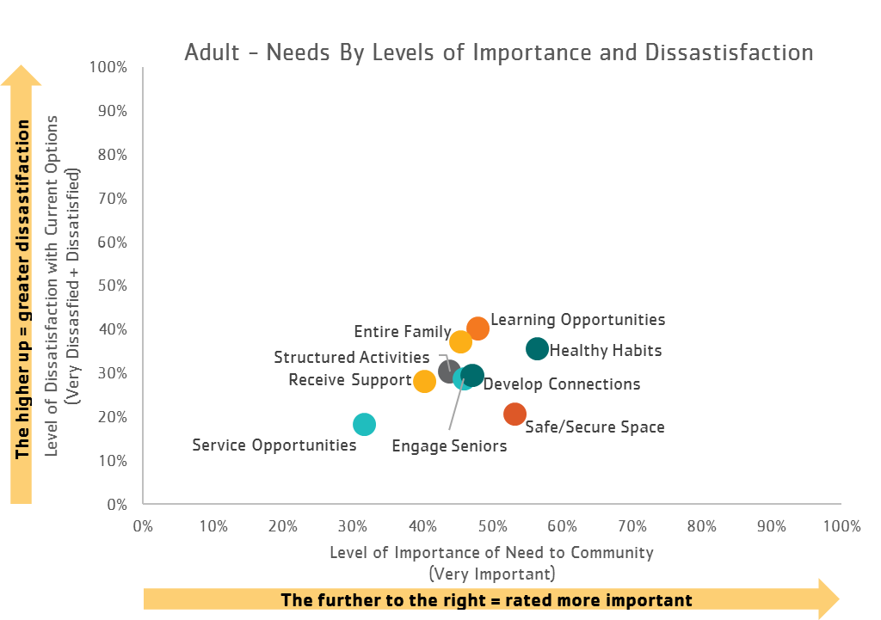

## Word Clouds

Using a word cloud generator (wordle.net), we identified the 50 most used words by respondents when answering the question: What is the most pressing need in this community relating to adults or youth/teens? In the diagram below, the size of the word is an indication of its frequency of use. The larger the word, the more it was used by respondents when they were describing needs.

### Most Pressing Need for *Adults*

*Please see the tab titled “Commentary” in the excel workbook to read through the full list of responses. The insight gained from these candid responses is invaluable.*

*“I feel that our community needs a larger YMCA so that the weight machines are not so crowded together. Also, newer and better weight machines would be beneficial, and more space for the mats would be nice.”*

*“Encouraging family values and the importance of supportive adults in our community to develop the next generation of leaders.”*

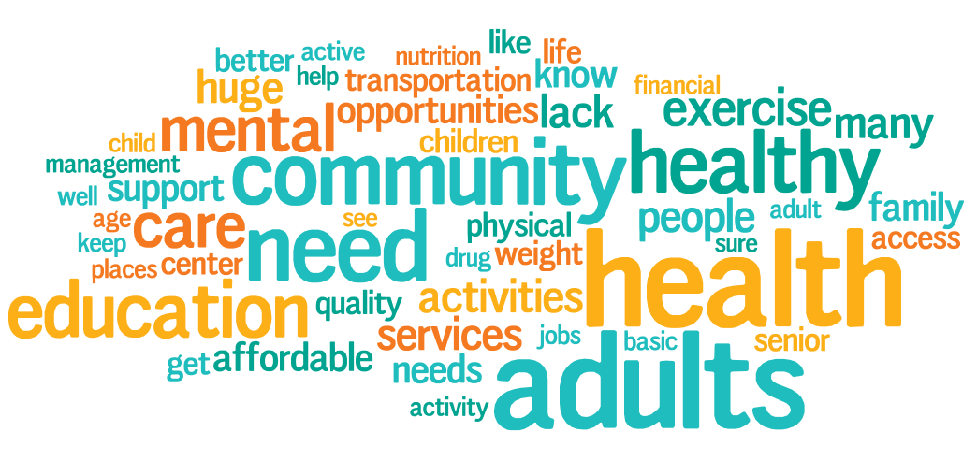

*“Nutrition and healthy lifestyle education (i.e., smoking cessation, stress management) and empathic parenting strategies (discipline versus punishment-based).”*

## TOP COMMUNITY NEEDS

The top identified community need for *youth* is availability of non-athletic programs that draw out youth skills, creativity, and confidence and youth exit high school with college or career readiness skills.

### Community Needs for *Youth/Teens*

|  |  |
| --- | --- |
| Results for Questions Relating to Youth/teens | % Identifying Topic as Community Need* |
| Availability of non-athletic programs that draw out youth skills, creativity, and confidence | 49.4% |
| Youth exit high school with college or career readiness skills | 49.4% |
| Youth are supported in practicing positive habits that include physical activity and healthy eating | 42.2% |
| Availability of academic support structures for youth outside of school (tutoring, mentoring, etc.) | 38.2% |
| Presence of community spaces where youth can develop connections with others | 37.6% |
| Youth have convenient access to structured activities in a community facility | 35.4% |
| Youth have opportunities to build good character | 33.3% |
| Safe and secure community spaces for our youth | 32.9% |
| Children enter into kindergarten prepared for success | 30.0% |
| Availability of service or volunteer opportunities for youth | 26.8% |

### Importance v. Satisfaction Charts

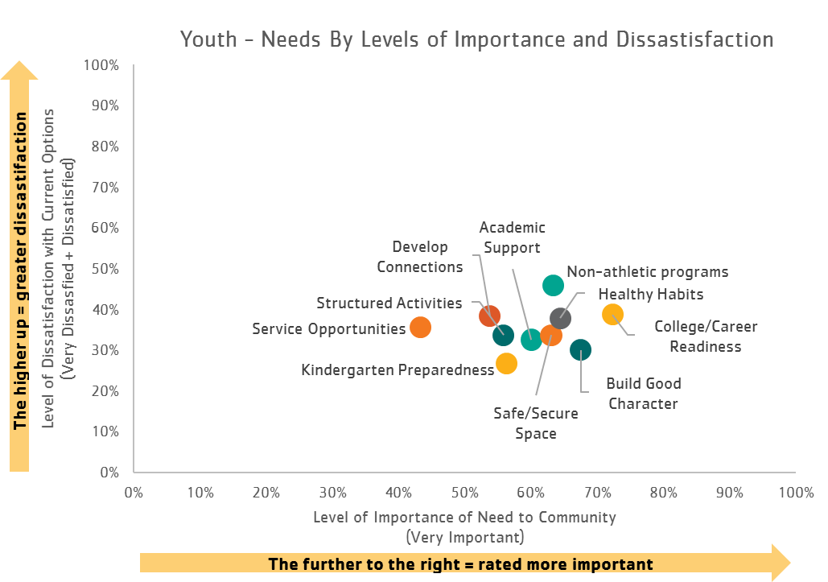This chart breaks out the needs by their level of importance and dissatisfaction giving you greater insight into why each received the percentage it did. It enables you to see which needs are more important v. which needs have a higher dissatisfaction with the current offerings in the community.Word Clouds

### Using a word cloud generator (wordle.net), we identified the 50 most used words by respondents when answering the question: What is the most pressing need in this community relating to adults or youth/teens? In the diagram below, the size of the word is an indication of its frequency of use. The larger the word, the more it was used by respondents when they were describing needs.

### Most Pressing Need for *Youth/Teens*

*Please see the tab titled “Commentary” in the excel workbook to read through the full list of responses. The insight gained from these candid responses is invaluable.*

*“The overall drug problem that is being ignored because of the parents, unknown and WELL KNOWN in the community, own addiction to said drugs. This "ignorance is bliss" mentality is the overall problem with the parents, which is causing a trickle down "its not a big deal" attitude THROUGHOUT the community.”*

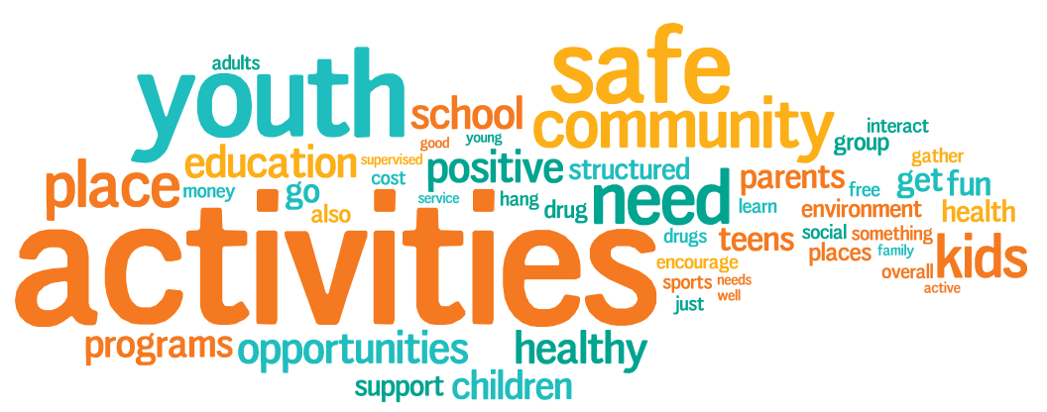

*“To provide services for youth of different age groups. There are very little opportunities for pre-teens and teens in Steuben County that provide healthy social interaction and growth.”*

*“Injury prevention during physical activity. Learning proper techniques for working out. Having loosely structured activities so youth can be creative. ”*

### Respondent Segmentation – *Demographics*

This section highlights the differences in response patterns that existed between the various demographic identifiers that were included in the survey. This information can prove to be quite useful for facilitating further discussion with each targeted group that has been identified.

* Non-members identified a significantly higher need than members for nearly all *youth and adult categories*.
* Respondents with children identified a significantly higher need for nearly all *youth categories* and for the *adult category* services aimed at engaging the entire family unit.
* Respondents without children identified a significantly higher need than those with children to engage the senior populations.
* Women responded higher needs than men for nearly all *youth* categories. Women also identified a significantly higher need than men for *adult categories* convenient access to structured activities, services aimed at engaging senior populations, and adults receiving support from groups.
* Men identified a significantly higher need than women for adults supported in practicing positive health habits.

### Respondent Segmentation - *Community*

This section highlights the responses by residential areas. **Zip code area 46703 had the highest response rate.**

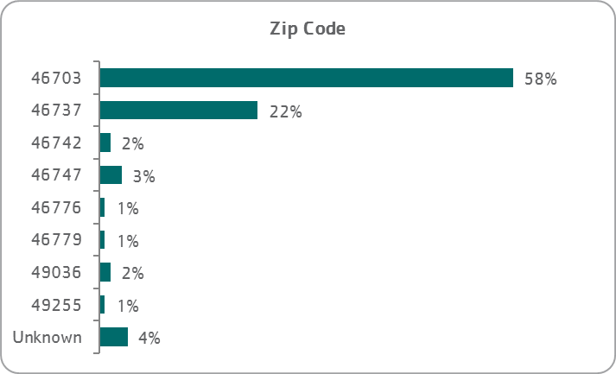

### Amenities

Additional questions were added to understand the community’s perceptions of various amenities to be added to the Steuben County YMCA. The question was asked in two ways: “Which of the following amenities would you **like to see built** in the open space by the Steuben County Y?” and “Of the amenities you would like to see built, **which one would you be most willing to contribute to financially**?”

The results show that respondents are most interested in and would financially support is an outdoor splash pad or a park. There are a great deal of “Other” comments that can be found in the Steuben County YMCA CNA Report – Data File.

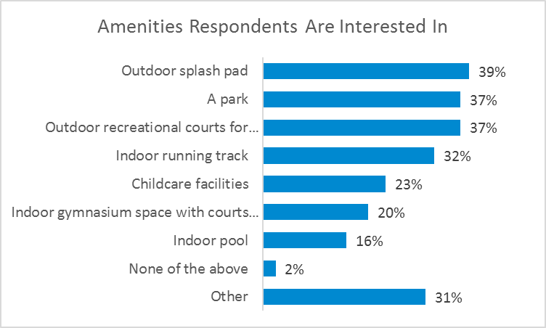

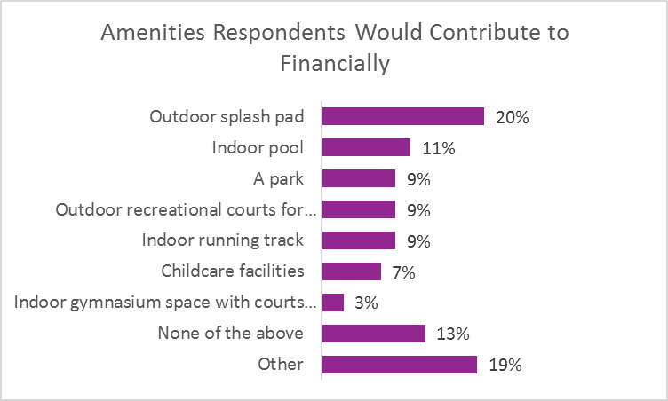

### YMCA Perception

This section highlights ways in which the community perceives the YMCA to currently be delivering on its cause and the three areas of focus of youth development, healthy living, and social responsibility. This information can prove useful in identifying areas where the Y can further develop positive perception in their community.

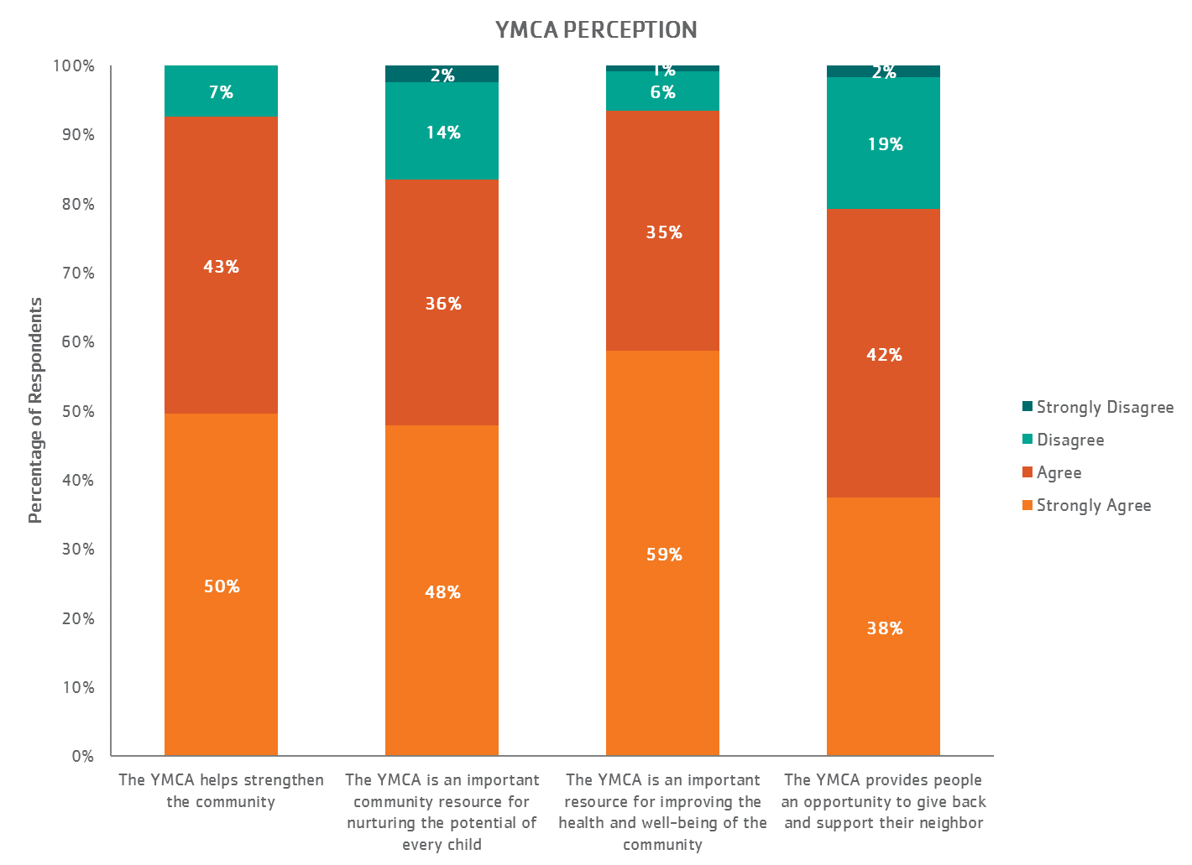

## Appendix - Full Survey Responses

### Rating 1 = Very Important; Very Satisfied Rating 2 = Important; Satisfied Rating 3 = Somewhat Important; Dissatisfied Rating 4 = Unimportant; Very Dissatisfied Rating 5 = Don’t Know; Don’t Know

|  |  |  |  |  |  |  |  |  |  |  |  |  |
| --- | --- | --- | --- | --- | --- | --- | --- | --- | --- | --- | --- | --- |
| COMMUNITY NEEDS | Importance of need | | | | | | Satisfaction with Need | | | | | |
| **Adult Needs** | *#* | *1* | *2* | *3* | *4* | *5* | *#* | *1* | *2* | *3* | *4* | *5* |
| Adults are supported in practicing positive habits that include physical activity & healthy eating | 124 | 56.5% | 33.1% | 9.7% | 0.8% | 0.0% | 121 | 5.8% | 51.2% | 31.4% | 4.1% | 7.4% |
| Adults have convenient access to structured activities in a community facility | 123 | 43.9% | 37.4% | 17.9% | 0.0% | 0.8% | 122 | 9.8% | 50.8% | 24.6% | 5.7% | 9.0% |
| Adults receiving support from groups within the community | 124 | 40.3% | 44.4% | 13.7% | 0.8% | 0.8% | 121 | 5.0% | 46.3% | 22.3% | 5.8% | 20.7% |
| Availability of learning opportunities for adults | 123 | 48.0% | 36.6% | 13.8% | 1.6% | 0.0% | 122 | 4.1% | 33.6% | 35.2% | 4.9% | 22.1% |
| Availability of service or volunteer opportunities for adults | 123 | 31.7% | 47.2% | 17.1% | 3.3% | 0.8% | 121 | 8.3% | 57.9% | 17.4% | 0.8% | 15.7% |
| Availability of services aimed at engaging the entire family unit | 123 | 45.5% | 32.5% | 17.1% | 4.1% | 0.8% | 121 | 2.5% | 38.8% | 30.6% | 6.6% | 21.5% |
| Availability of services that engage senior population | 124 | 46.0% | 39.5% | 12.1% | 0.8% | 1.6% | 122 | 4.9% | 42.6% | 21.3% | 7.4% | 23.8% |
| Presence of community spaces where adults can develop connections with others | 123 | 47.2% | 32.5% | 17.9% | 1.6% | 0.8% | 122 | 3.3% | 47.5% | 21.3% | 8.2% | 19.7% |
| Presence of safe and secure community spaces for adults | 122 | 53.3% | 32.8% | 12.3% | 1.6% | 0.0% | 121 | 10.7% | 49.6% | 17.4% | 3.3% | 19.0% |
| **Youth Needs** | *#* | *1* | *2* | *3* | *4* | *5* | *#* | *1* | *2* | *3* | *4* | *5* |
| Availability of academic support structures for youth outside of school (tutoring, mentoring) | 120 | 60.0% | 26.7% | 6.7% | 0.8% | 5.8% | 120 | 4.2% | 26.7% | 25.0% | 7.5% | 36.7% |
| Availability of non-athletic programs that draw out youth skills, creativity, and confidence | 120 | 63.3% | 27.5% | 3.3% | 0.8% | 5.0% | 120 | 2.5% | 20.8% | 35.8% | 10.0% | 30.8% |
| Availability of service or volunteer opportunities for youth | 120 | 43.3% | 40.8% | 10.8% | 0.0% | 5.0% | 119 | 2.5% | 31.4% | 29.7% | 5.9% | 30.5% |
| Children enter into kindergarten prepared for success | 119 | 56.3% | 28.6% | 8.4% | 0.0% | 6.7% | 120 | 5.0% | 35.0% | 23.3% | 3.3% | 33.3% |
| Presence of community spaces where youth can develop connections with others | 119 | 53.8% | 37.8% | 2.5% | 0.8% | 5.0% | 119 | 5.0% | 27.5% | 30.8% | 7.5% | 29.2% |
| Safe and secure community spaces for our youth | 119 | 63.0% | 29.4% | 2.5% | 0.0% | 5.0% | 119 | 7.6% | 31.1% | 27.7% | 5.9% | 27.7% |
| Youth are supported in practicing positive habits that include physical activity & healthy eating | 118 | 64.4% | 27.1% | 3.4% | 0.0% | 5.1% | 120 | 2.5% | 31.1% | 30.3% | 7.6% | 28.6% |
| Youth exit high school with college or career readiness skills | 119 | 72.3% | 21.0% | 0.8% | 0.0% | 5.9% | 118 | 1.7% | 26.9% | 31.1% | 7.6% | 32.8% |
| Youth have convenient access to structured activities in a community facility | 120 | 55.8% | 30.0% | 7.5% | 0.0% | 6.7% | 120 | 3.4% | 31.9% | 26.9% | 6.7% | 31.1% |
| Youth have opportunities to build good character | 120 | 67.5% | 22.5% | 4.2% | 0.0% | 5.8% | 119 | 4.2% | 33.3% | 21.7% | 8.3% | 32.5% |